7.67: a) Taking 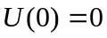,

b)
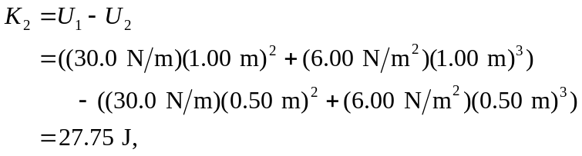
and so 

